REST - Country Web Service
Package structure:
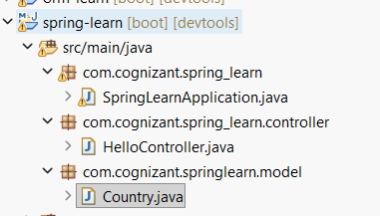
Country class:
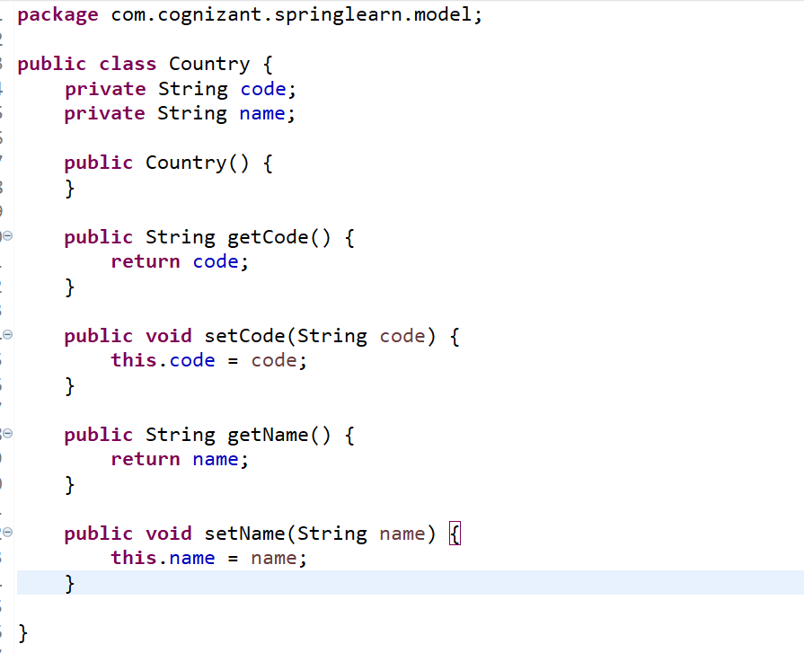

Country.xml file
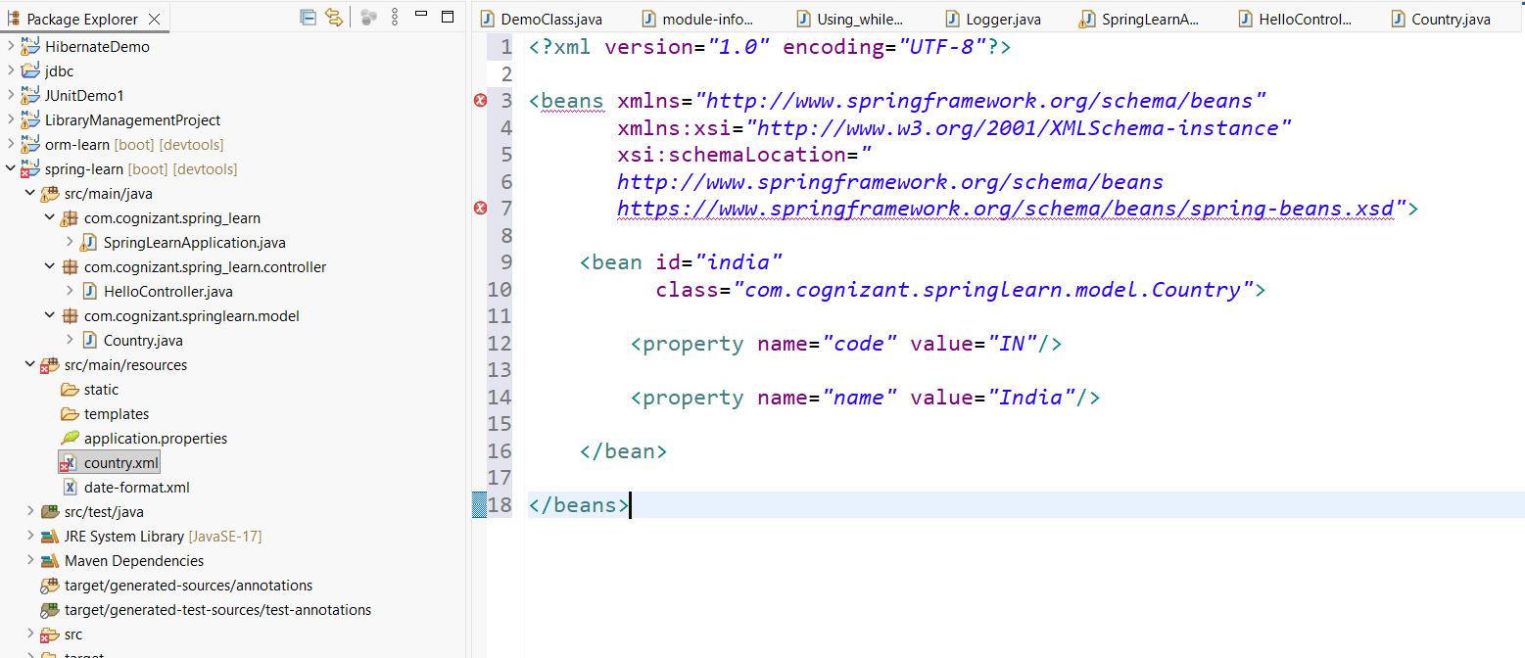
CountryController java class
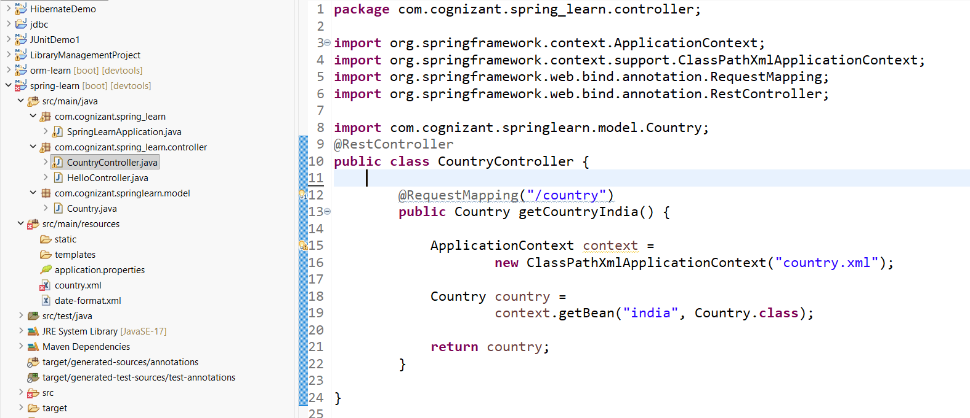
Testing in browser
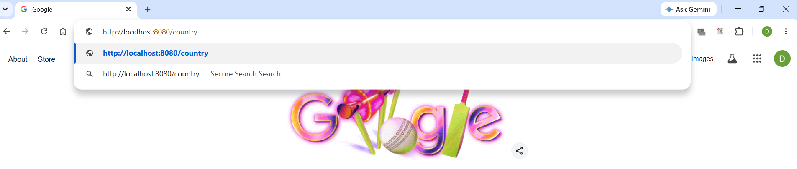
Browser output(display)
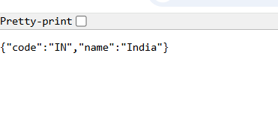
Postman
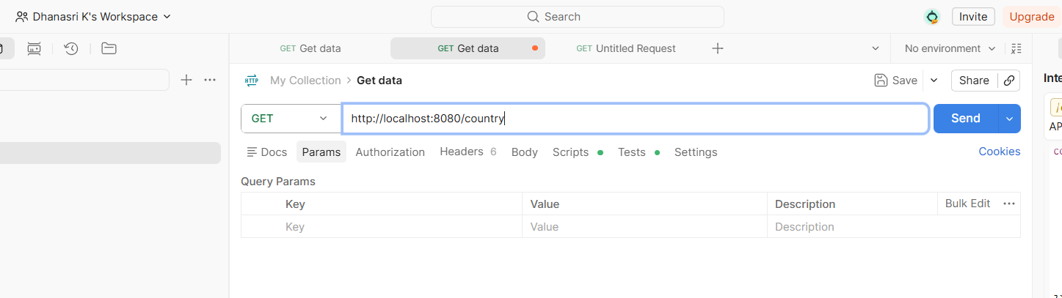
Output from postman
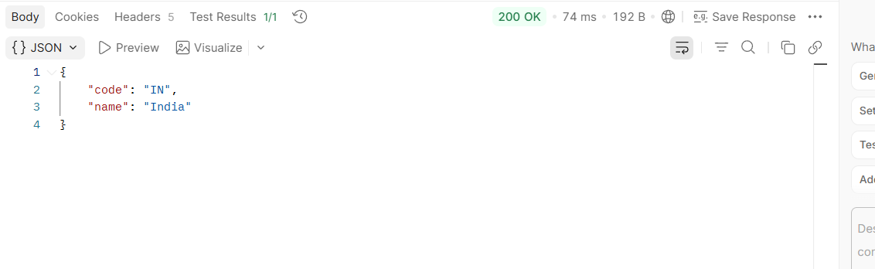
SME to explain the following aspects:

What happens in the controller method?
Step-by-step explanation
When the client sends a request to
http://localhost:8083/country
the following happens:
Step 1
The browser sends an HTTP GET request to
/country
↓
Step 2
Spring Boot receives the request.
↓
Step 3
The DispatcherServlet (Front Controller) receives the request.
Its job is to find which controller method should handle the request.
↓
Step 4
It finds
@RequestMapping("/country")
Therefore it calls
getCountryIndia()
↓
Step 5
Inside the method,
ApplicationContext context =
new ClassPathXmlApplicationContext("country.xml");
Spring reads the
country.xml
configuration file.
↓
Step 6
Spring creates the bean defined in XML.
<bean id="india" ...>
↓
Step 7
Now
context.getBean("india", Country.class);
retrieves the bean named
india
↓
Step 8
The retrieved bean contains
code = IN
name = India
↓
Step 9
The controller returns the Country object.
return country;
2) How is the bean converted into JSON response?
This is one of the most important Spring Boot concepts.
Step 1
The controller returns
Country
object.
Not JSON.
↓
Step 2
Because the class has
@RestController
Spring understands
"The returned object should be sent directly in the HTTP Response Body."
↓
Step 3
Spring Boot automatically uses the Jackson library.
Jackson converts
Country Object
↓
into
{
"code":"IN",
"name":"India"
}
This process is called
Serialization.
↓
Step 4
The generated JSON is placed inside the
HTTP Response Body.
↓
Step 5
The browser/Postman displays the JSON.
3)In Network tab show the HTTP header details received
Open
http://localhost:8083/country
Press
F12
↓
Network
↓
Refresh the page
↓
Click
country
↓
Headers
You will see three sections.
General
Example
Request URL: http://localhost:8083/country
Request Method: GET
Status Code: 200 OK
Meaning
- Which URL was requested.
- Which HTTP method was used.
- Whether the request succeeded.
Request Headers
These are sent by the browser.
Example
Host: localhost:8080
User-Agent: Mozilla/5.0
Accept: application/json
Meaning
The browser tells the server
- who it is
- which host it wants
- which response formats it accepts
Response Headers
These are sent by Spring Boot/Tomcat.
Example
Content-Type: application/json
Content-Length: 29
Date: Tue,...
Connection: keep-alive
Meaning
Content-Type
application/json
The server is informing the browser that the response body contains JSON.
Content-Length
Size of the JSON response in bytes.
Date
Time when the response was generated.
Connection
Whether the HTTP connection is kept alive.
4) In Postman click on "Headers" tab to view the HTTP header details received
Step 1
Open Postman.
Choose
GET

Step 2
Enter
http://localhost:8080/country
Click
Send

Step 3
You will see the JSON response.
{
"code":"IN",
"name":"India"
}

Step 4
Now click
Headers
This is located beside the Body tab in the response section.
There you will see something similar to
Content-Type: application/json
Content-Length: 29
Date: ...
Connection: keep-alive
These are the response headers returned by your Spring Boot application.

